DATE: 2016.06.22

ASR 6198 : Inbound creation to allow import Detail line from excel file:

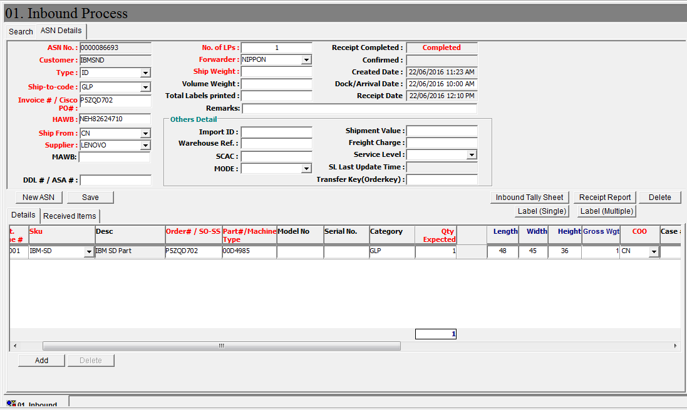

Import detail

1. Add button **[Import Detail]**
2. Import template file format:

|  |  |  |  |  |  |  |  |  |  |  |
| --- | --- | --- | --- | --- | --- | --- | --- | --- | --- | --- |
| Order# | Part#/Machine Type | Model no | Serial no | Category | Qty exp. | L | W | H | Wgt | COO |
|  |  |  |  |  |  |  |  |  |  |  |

1. System auto insert row to ASN detail.

WMS Changes:

1. Inbound Creation

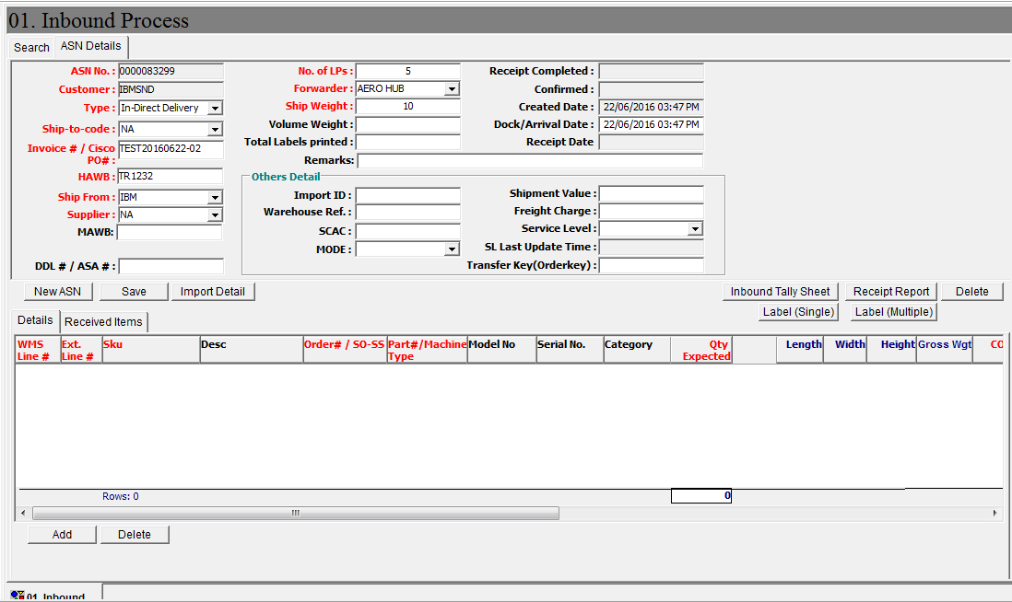

Import ASN Detail function

Click [Import Detail] – windows screen pop put to select import file,

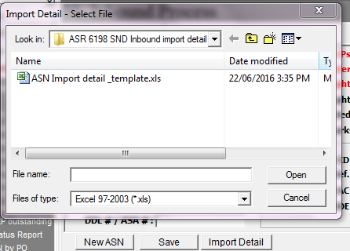

Click Open to continue import

System will auto –insert detail lines.

After confirm, user needs to click [**Save**] to save the records into system.

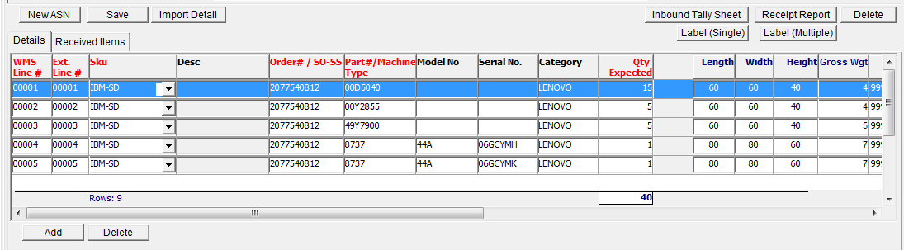

Sample Template – import detail:

